SQL Exercise 8

**Purpose:** Nine SQL exercises will be released throughout the quarter. These assignments will help you connect and manipulate a database through Python. Python-to-SQL is a parallel strand of knowledge that you would gain in this class.

**Reference:** 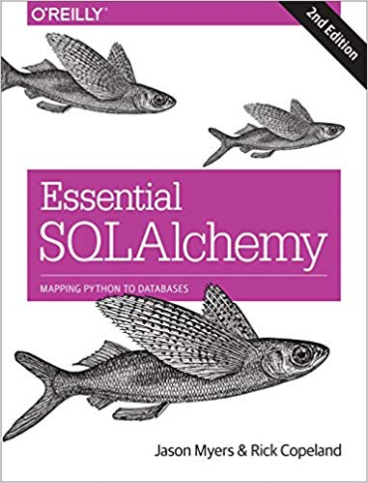

**Code:** Time to practice! Try the code below and get it to work. The code is pre-tested and should run “as is.” Verify what you type if an error persists. Press “Run” to every time you completed a jupyter cell. Because you already have content knowledge of what is a database, most of the code are self-explanatory.

***Instructions:*** *Start a new Python project folder … do not reuse the previous workspace … As with any keyboard-driven console-like environment, developing muscle -memory for the common commands is also part of the learning curve.*

**Viewing database:** To view the database created by Python, you may use a SQL Lite viewer. This tool is posted inside Week #2 in Canvas; look for DB.Browser.for.SQLite-3.10.1-win64

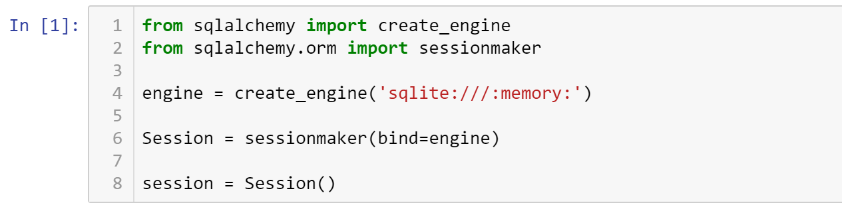

Some of these codes may look repeated, but they are here for a different purpose.

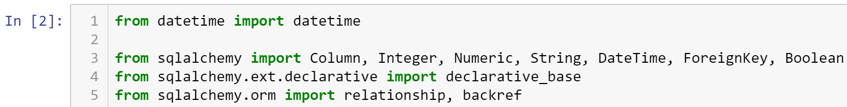

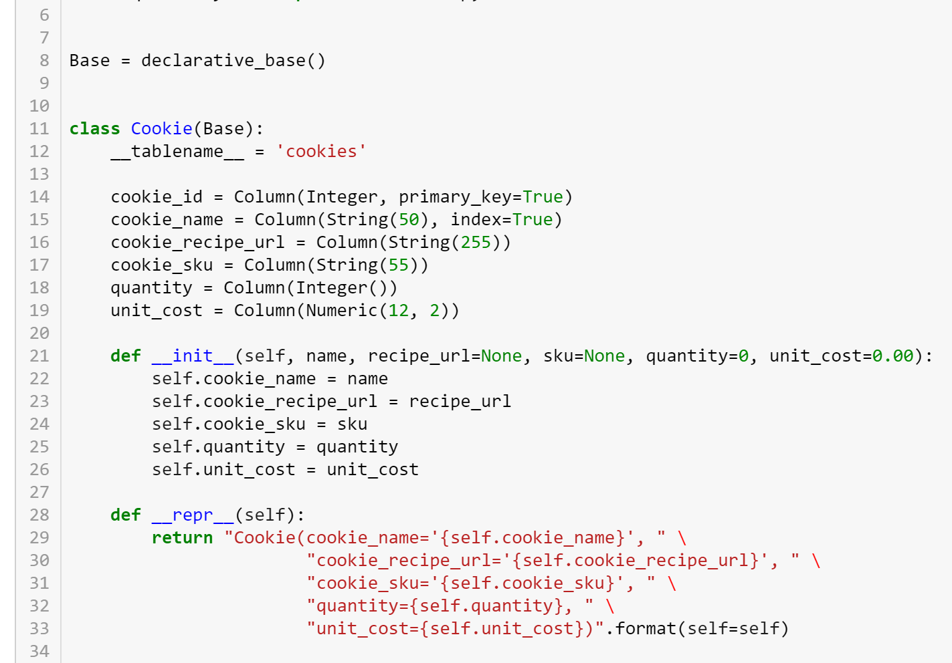

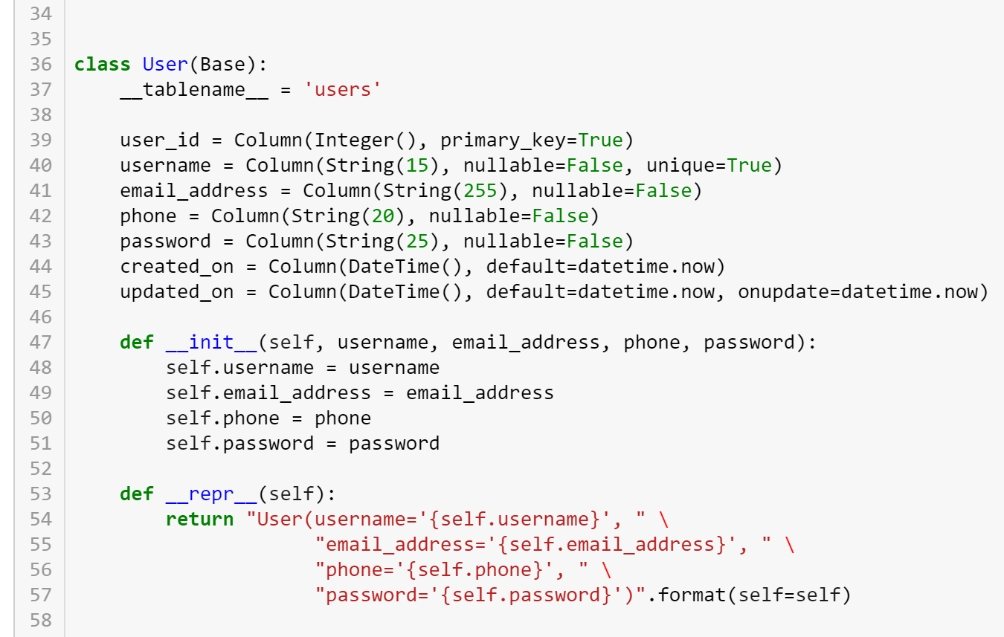

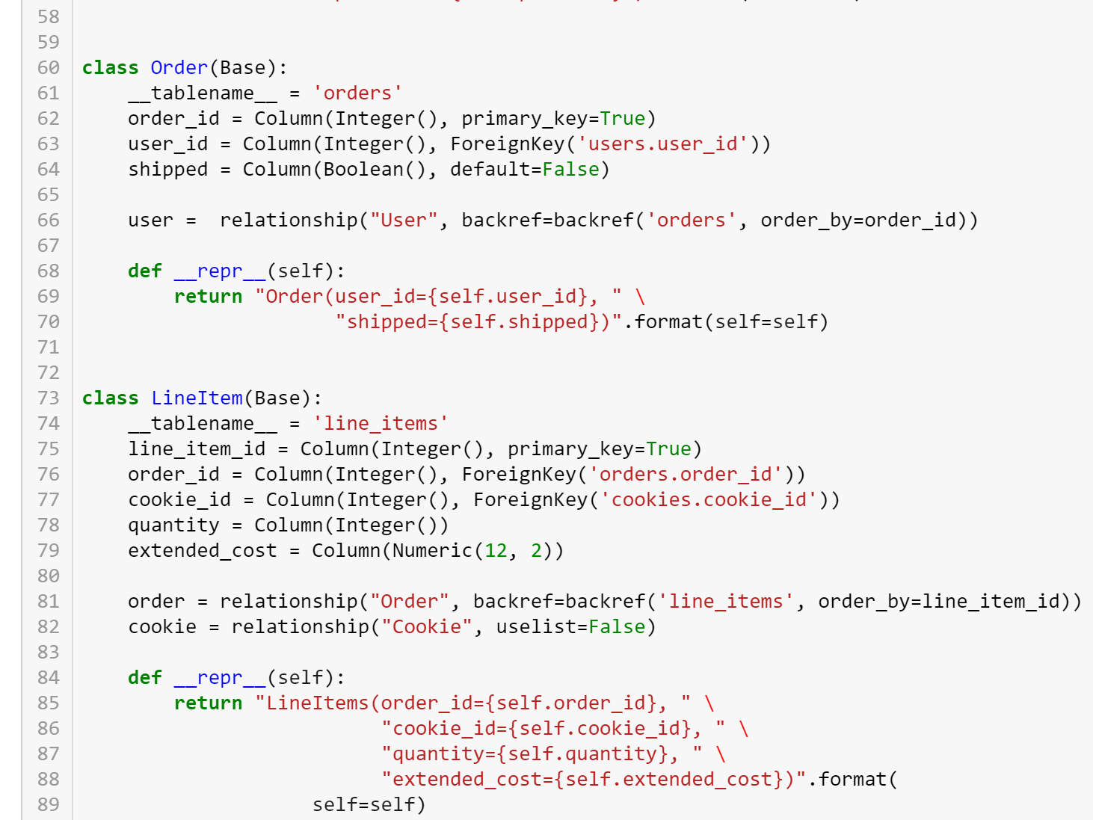



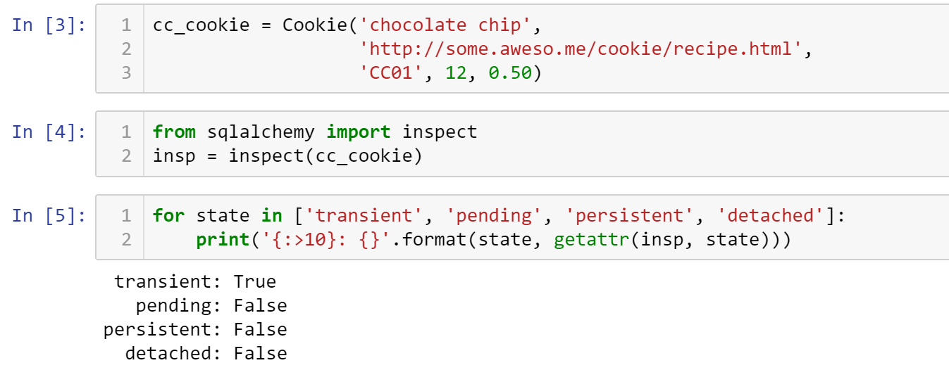



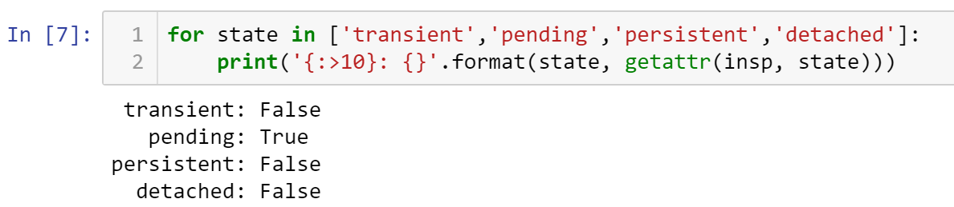

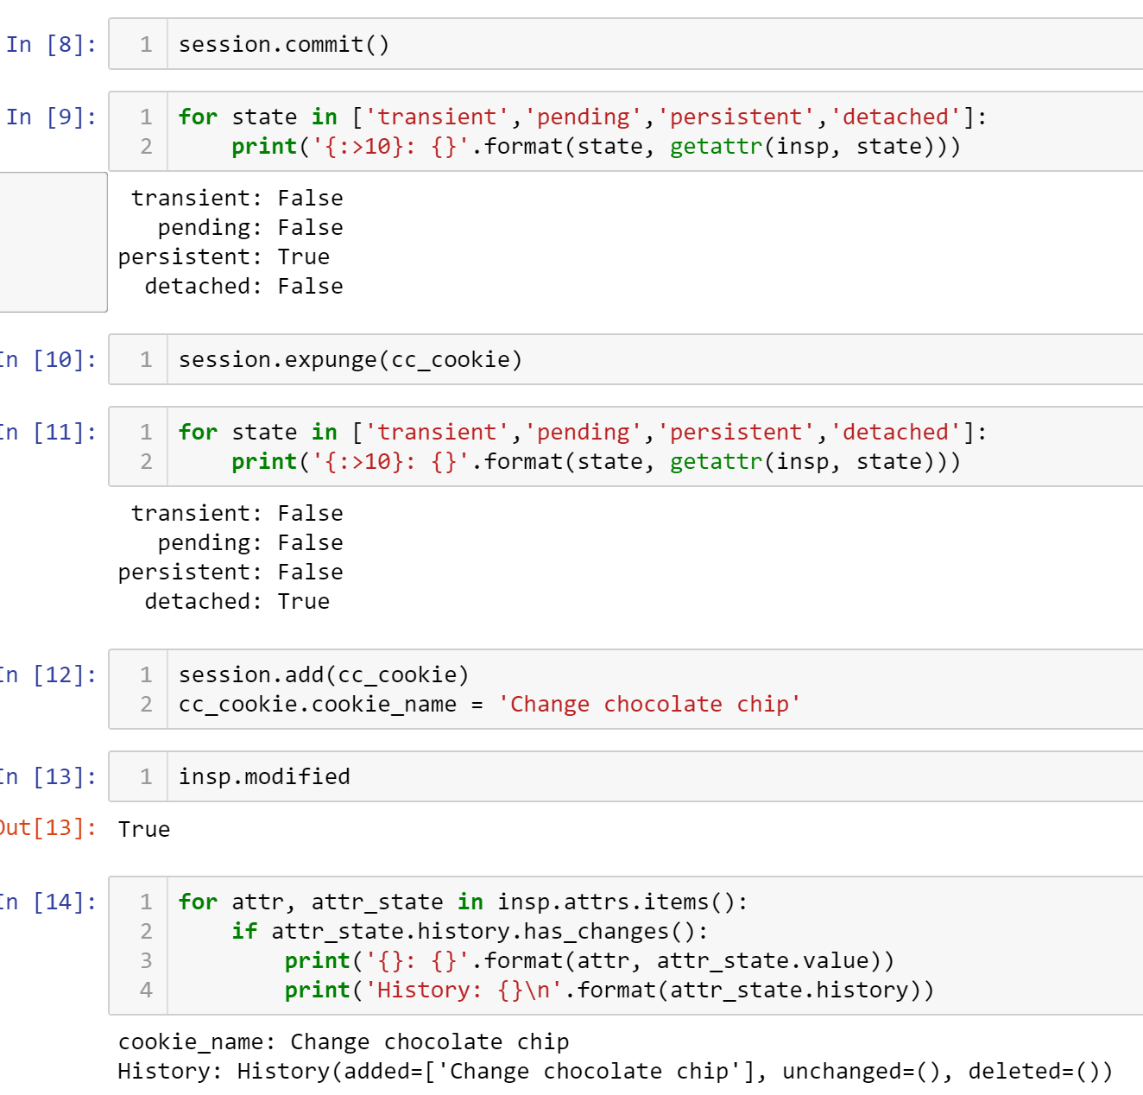

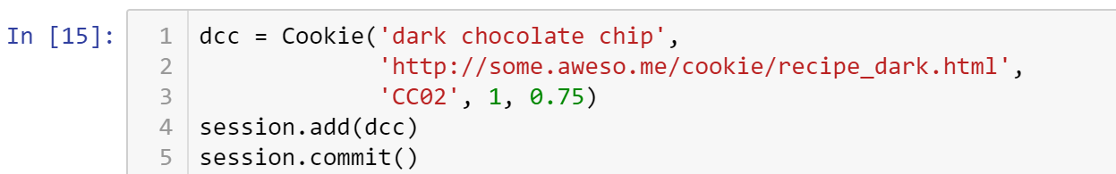

/Users/jasomyer/.virtualenvs/sa-book/lib/python2.7/site-packages/sqlalchemy/sql/sqltypes.py:565: SAWarning: Dialect sqlite+pysqlite does *not* support Decimal objects natively, and SQLAlchemy must convert from floating point - rounding errors and other issues may occur. Please consider storing Decimal numbers as strings or integers on this platform for lossless storage.

'storage.' % (dialect.name, dialect.driver))



Inserting the same record will result in an error.

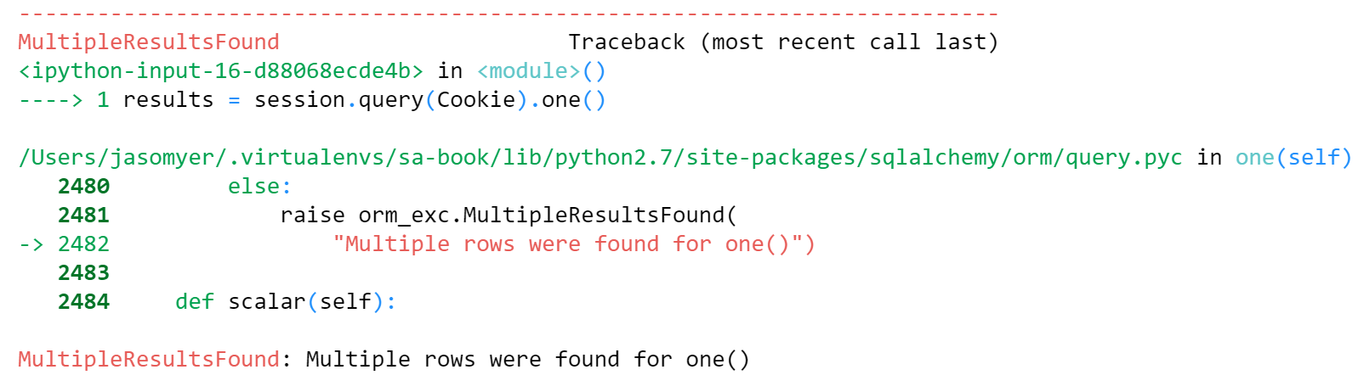

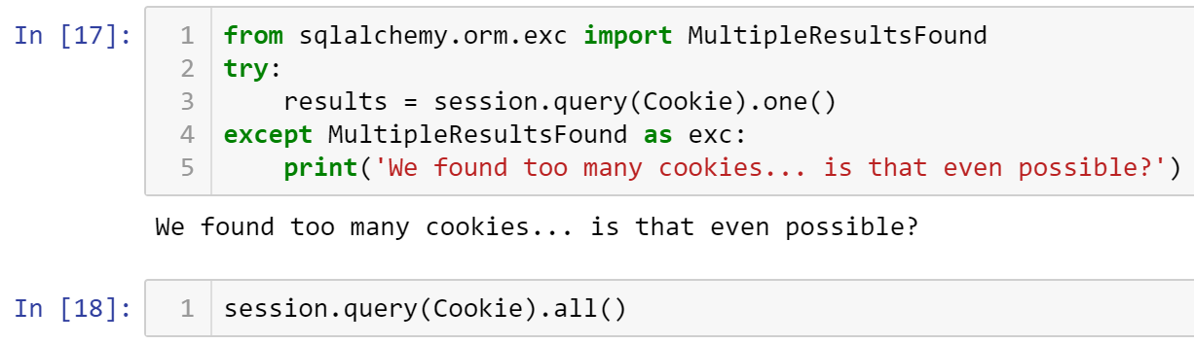

[Cookie(cookie_name='Change chocolate chip', cookie_recipe_url='http://some.aweso.me/cookie/recipe.html', cookie_sku='CC01', quantity=12, unit_cost=0.50),

Cookie(cookie_name='dark chocolate chip', cookie_recipe_url='http://some.aweso.me/cookie/recipe_dark.html', cookie_sku='CC02', quantity=1, unit_cost=0.75)]

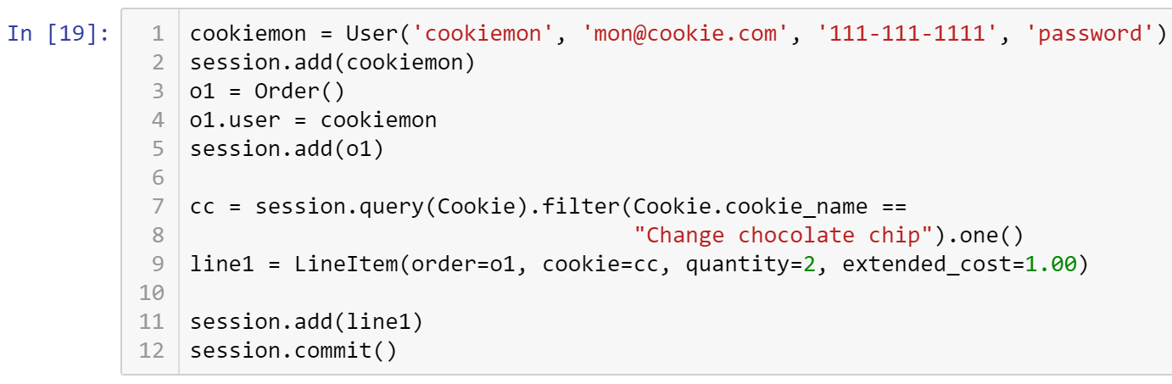

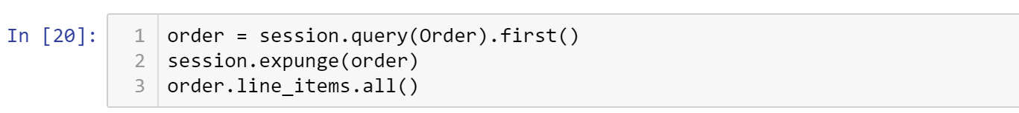

You may get a data integrity error. That is when the main records are detached from its associated detail lines.

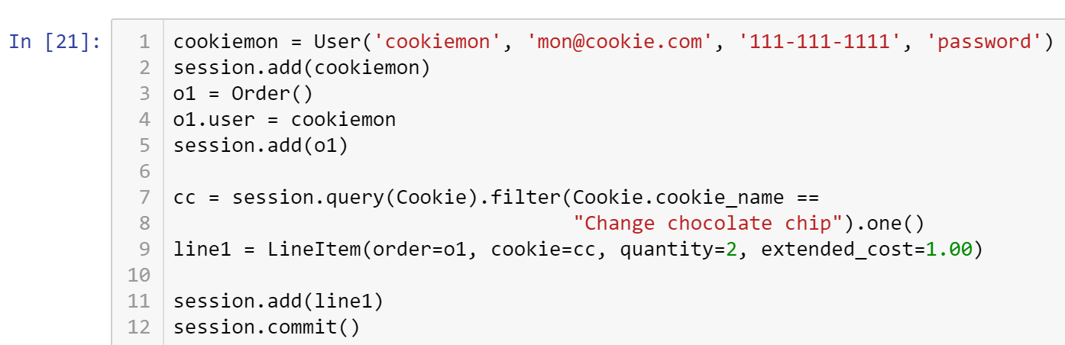



InvalidRequestError: This Session's transaction has been rolled back due to a previous exception during flush. To begin a new transaction with this Session, first issue Session.rollback(). Original exception was: (raised as a result of Query-invoked autoflush; consider using a session.no_autoflush block if this flush is occurring prematurely) (sqlite3.IntegrityError) UNIQUE constraint failed: users.username [SQL: u'INSERT INTO users (username, email_address, phone, password, created_on, updated_on) VALUES (?, ?, ?, ?, ?, ?)'] [parameters: ('cookiemon', 'mon@cookie.com', '111-111-1111', 'password', '2015-08-11 20:29:22.988774', '2015-08-11 20:29:22.988786')]

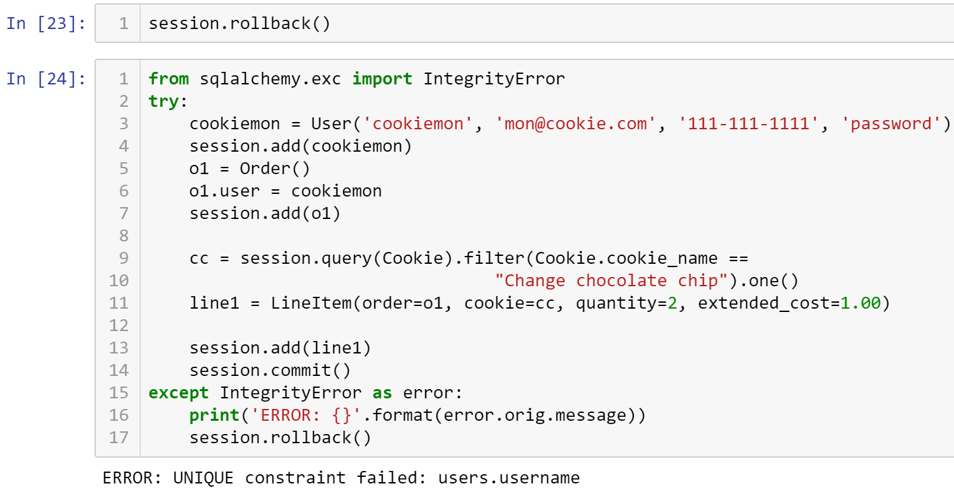

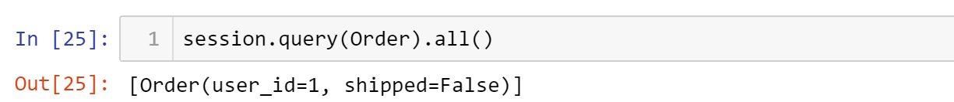

* **Critical Thinking Section:** In your own words, explain in a paragraph (5 sentences or more) describing what is a data integrity error.
* Place your answer here below:

|  |
| --- |
|  |

* Place your name at the bottom of your code, download your Python program in html format, and submit your work in Canvas.

**Viewing database:** To view the database created by Python, you may use a SQL Lite viewer. This tool is posted inside Week #2 in Canvas; look for DB.Browser.for.SQLite-3.10.1-win64

**Important:** All submissions should be separate from other exercises and quests. Please do not lump all your answers into one document and re-using that same workspace to gain multiple points. Thanks.